BASIC PREPARATIONS
To operate a Zactrack System, some basic preparations are necessary.
Connect the Zactrack Server as seen in the lower picture. Each Anchor needs a POE supply. It is possible to use different switches. See also Network
Put the Trackers in the charging station and connect a 5V USB power supply. Wait until the trackers are fully charged (green constant light).
Also charge the 4 Pucks, with the USB cable. They are only necessary for a setup process.

Hardware Setup Overview
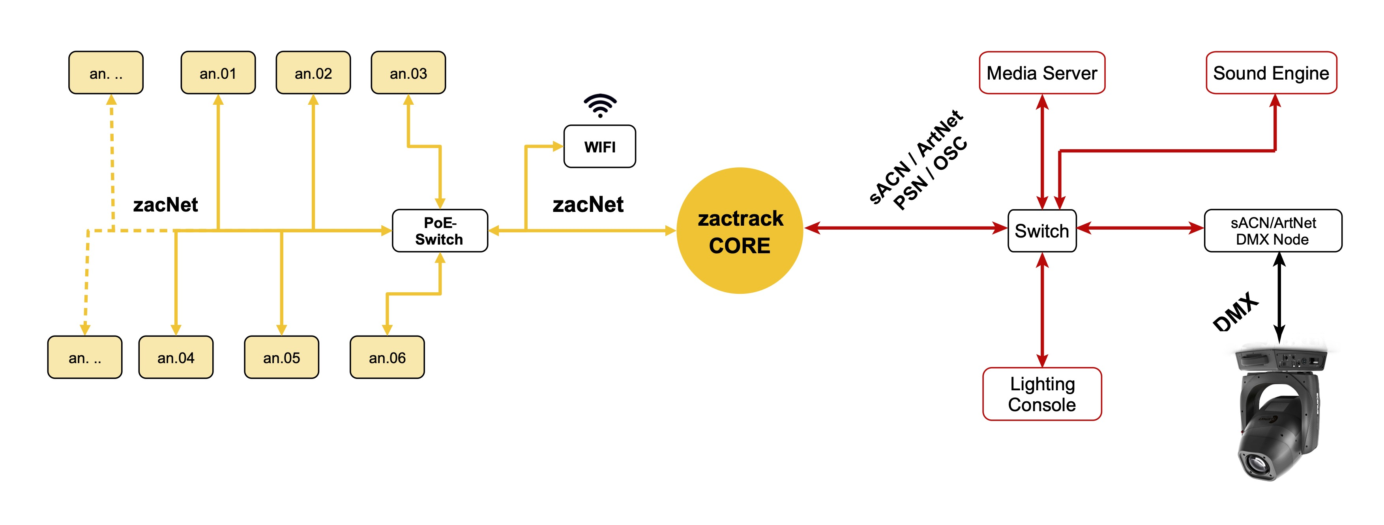

A zactrack Setup could look like this
In this example a Main and a Backup Server is used. Attention a Zactrack Smart System is limited at 8 Anchors!


